Sociodemographic Comparison of Caribbean Hispanic Older Adult Immigrants in the U.S. and Origin Countries

William H. Dow, PhD (Corresponding author)

University of California, Berkeley

[wdow@berkeley.edu](mailto:wdow@berkeley.edu)

Chris Soria, MA

University of California, Berkeley

[chrissoria@berkeley.edu](mailto:chrissoria@berkeley.edu)

Henry T. Dow

University of California, Berkeley

[htdow@berkeley.edu](mailto:htdow@berkeley.edu)

March 26, 2025

Sociodemographic Comparison of Caribbean Hispanic Older Adult Immigrants in the U.S. and Origin Countries

Abstract

**Background and Objectives:** Over 30 percent of older adult Hispanic immigrants in the U.S. in 2020 were born in the Caribbean countries of Cuba, Dominican Republic, and Puerto Rico. We explore heterogeneity in the sociodemographic determinants of healthy aging of immigrants from these under-studied countries and compare them to those from Mexico.

**Research Design and Methods:** We compare adults ages 60 and over in these sending countries’ Census data to country-specific immigrant samples in the U.S. American Community Survey. We analyze patterns of education, co-residence, and migration timing and assimilation characteristics including language and citizenship.

**Results:** Immigrant characteristics and selectivity patterns vary markedly across these countries and by cohort. Caribbean older adult immigrants have substantially higher education and citizenship levels than those from Mexico, but are less likely to be married or live with children. Dominican immigrants are most similar to those from Mexico, but have even stronger positive immigrant selectivity on education. These patterns have evolved in recent decades, with rising citizenship and English-speaking among Mexican and Dominican immigrants, and markedly increased education among those both remaining in and immigrating from all four of these countries.

**Discussion and Implications:** As these countries and the characteristics of their immigrants have been rapidly changing, it will be valuable to continue understanding changes in their heterogeneous healthy aging patterns. This will be enabled by harmonized research such as through the global family of health and retirement studies, including the ongoing Caribbean American Dementia and Aging Study (CADAS).

**Keywords**: International comparisons, Latin America, Cuba, Dominican Republic, Mexico, Puerto Rico.

## Introduction

Among Hispanics ages 60 and above in the U.S., 64 percent are immigrants (2016-2020 American Community Survey (ACS)). There is considerable heterogeneity by cohort and country of origin in the sociodemographic characteristics of these older adult Hispanic immigrants, just as there is between those non-immigrants living in their native Latin American countries. Mexican immigration patterns have been extensively studied, justifiably so given that 44 percent of older adult Hispanic immigrants in the U.S. were born in Mexico (we refer to “older adults” as those ages 60 plus, and cite U.S. immigrant data from the 2016-2020 American Community Survey (ACS)). Less studied has been the over 30 percent of older U.S. Hispanic immigrants from the next three largest senders: the Hispanic Caribbean countries Puerto Rico, Cuba, and the Dominican Republic (Table 1).

In this paper we explore sociodemographic variation of U.S. older adult immigrants by country and cohort of migration, comparing these U.S. immigrants to the corresponding cohorts of older adults living in their countries of origin, elucidating heterogeneity across these three Hispanic Caribbean populations and their comparison with the better-studied patterns from Mexico. We also highlight rapid changes across birth cohorts in characteristics such as education.

We focus on key sociodemographic determinants of healthy aging included in the largest representative household survey dataset in the U.S. with reported country of origin, the ACS, as well as those characteristics that can be comparably measured in Census data from these four origin countries. These include patterns of education and co-residence, and among U.S. immigrants their migration timing and assimilation characteristics including language and citizenship. Together these factors help determine the health risks and possibilities for healthy aging. Systematically documenting them will support future research to better understand existing heterogeneity in older adult Hispanic health and mortality, and hypothesis generation regarding future evolution of healthy aging trends in these populations.

With the growing understanding of implications of early life conditions for later adult health, it can be particularly valuable to study immigrants in comparison to older adults living in their countries of origin. This is aided by better understanding variation in immigration selectivity patterns. An intriguing aspect of the Hispanic Caribbean is the especially high ratio of older adults born in the Hispanic Caribbean who are currently living in the U.S.: for every 100 older adults living in Mexico there are currently 11 Mexican immigrants living in the U.S., but the corresponding ratios are 17 for Dominicans, 19 for Cubans, and a remarkable 53 for Puerto Ricans. Comparative research to better understand cross-country aging patterns is being enabled by the growing global family of harmonized health and retirement studies, including the new Caribbean American Dementia and Aging Study (CADAS) which is studying Puerto Rico and the Dominican Republic (Llibre-Guerra et al. 2021) and with which parallel data are being collected in Cuba, as well as the long-running Mexican Health and Aging Study (MHAS) and the U.S. Health and Retirement Study (HRS) (Wong, Michaels-Obregon, Palloni 2017; Sonega et al., 2014). The current paper is designed to provide high-level demographic context to the growing body of research on healthy aging among Caribbean-origin populations and comparisons with Hispanics elsewhere.

## Background

Latin American and Caribbean countries are major sources of immigrants to the United Sates. In 2022, people of Mexican origin (regardless of birthplace) made up 59 percent of the U.S. Hispanic population across all ages, totaling about 37.4 million. Puerto Ricans were the next largest group at 5.9 million, with an additional 3.2 million living on the island. Cubans and Dominicans were the fourth and fifth largest Hispanic origin populations, with 2.4 million each in the U.S. (Noe-Bustamante 2023). These Hispanic populations include large subgroups who are immigrants aged 60 and above, with 1.8 million from Mexico and then the three Hispanic Caribbean countries being the next largest origin of older adults with over 1.25 million combined (Table 1).

These international migration patterns are shaped by a complex interplay of factors, including labor markets, educational opportunities, and political and economic instability (McAuliffe, Bauloz, and Kitimbo 2024; Valentine et al. 2017). Informal factors are instrumental as well, with family reunification and social networks helping to motivate and facilitate migration (Massey et al. 1994; Silva and Massey 2014).

Economic factors underlying migration from Latin America to the U.S. have been conceptualized using push-pull migration theory (Hanson, Orrenius, and Zavodny 2023). Economic insecurity in Latin American countries acts as a push factor (Capielo Rosario et al. 2023; Larotta Silva 2019), while periods of U.S. economic growth pull migrants with increasing employment opportunities and growing wage differentials (Bahar 2024).

Alongside economic factors, political instability has been a significant driver of migration from Latin American countries to the U.S. (FitzGerald and Arar 2018). In the Hispanic Caribbean, the Cuban Revolution of 1959 started the largest refugee movement to the United States in history (Duany 2017); the Cuban Adjustment Act of 1966 and subsequent policies, such as the “wet foot, dry foot” policy (1995-2017), have significantly influenced Cuban migration to the United States. This has been followed by large subsequent flows from countries elsewhere with political instability (González 2024); e.g., in the first 11 months of 2023, over 50% of approximately 412,000 asylum applications to the U.S. Department of Homeland Security came from Venezuela, Cuba, Colombia, and Nicaragua (U.S. Customs and Border Protection 2024). By contrast, Puerto Rico’s special status as a U.S. territory since 1898 has facilitated legal entry to the U.S. mainland for its residents. This illustrates how political arrangements can create facilitated migration channels, potentially leading to what migration theorists term “migration systems” or “transnational social spaces” (Kritz, Lim, and Zlotnik 1992).

Other changes in U.S. immigration policy have also shaped the patterns of flows from different countries. In the below analysis we examine the varying migration timing of older adult immigrants currently in the U.S., distinguishing several broad periods. The period before 1965 was characterized by relatively higher immigration from Puerto Rico but also the initial wave of post-Castro Cuban immigration; its end is marked by the passage of the 1965 Immigration and Naturalization Act that shifted away from country quotas and towards family reunification, and the 1964 end of the Mexican Bracero program. The period from 1965-1979 captures the subsequent rapid rise of permanent Mexican immigration; the 1980-99 period covers the Reagan-era Immigration Reform and Control Act of 1986 and a period of rapid increase in Dominican immigration. The post-2000 period captures more recent inflows, which includes mid-to later-adult migration among the current population of older adult immigrants.

Of particular interest for the present study are the selection processes impacting the sociodemographic characteristics of migrants in any given country cohort. Age is among the starkest determinants of migration, with working age adults typically dominating flows, while older individuals migrate less frequently. There are also varying patterns of selection by education, depending on other immigration determinants (Hanson, Orrenius, and Zavodny 2023). The current study is not able to analyze selectivity by health status; a large body of previous research has investigated positive selectivity on health attributes (Feliciano 2020), and we encourage future work to build on this paper to better understand health selectivity in the Hispanic Caribbean.

## 

## Data and Methods

***Samples***

We compare adults ages 60 and over in our focal Hispanic Caribbean countries (Cuba, Dominican Republic, and Puerto Rico) and Mexican census data to country-specific immigrant samples in the U.S. American Community Survey.

U.S. data is from the American Community Survey (ACS) provided by IPUMS (Ruggles, Flood et al. 2024), which is the largest representative household survey in the U.S. that reports country of birth. The most recent available ACS data in our analysis pools the 2016-2020 repeated cross-sections for sufficient sample sizes. For certain comparisons we also present data from roughly a decade earlier, using the 2008-10 pooled ACS samples (waves earlier than this are less comparable due to different variable coding). For presentation purposes we refer to these as the 2020 and 2010 ACS data. Puerto Rican migrants are defined as those born in Puerto Rico who are living in the 50 United States or District of Columbia at the time of the survey.

For Hispanic Caribbean populations we analyze census microsamples provided by IPUMS International (Ruggles, Cleveland et al. 2024). The most recent available census data at IPUMS for Dominican Republic and Cuba are from 2010 and 2012, respectively. Puerto Rico and Mexico each have census data available from both 2010 and 2020; we use 2010 for our main analyses for purposes of comparability with Dominican Republic and Cuba, but report analyses using 2020 in the supplemental tables. We do not attempt to correct for census undercounts, as differential undercounts by sociodemographic characteristics are not available across our measures of interest.

Within each sample we analyze all individuals ages 60 and over. In the U.S. data we stratify by self-reported country of birth, presenting data for those born in each of our three Hispanic Caribbean focal countries and Mexico, as well as those born in Central America, elsewhere in Latin America, and the rest of the world. For comparison purposes we separately show data for US-born older adults stratified by self-reported race/ethnicity: Hispanics, and non-Hispanic Blacks, Whites, and others.

All analyses are weighted by person-weights provided by IPUMS to make the results nationally representative for the relevant group. The supplemental tables include an analysis that age-standardizes results by 5-year age group to the U.S. population; because we interpreted the patterns to not be meaningfully different when age-standardized, we present the more transparent unstandardized results in the main analysis. Given the large sample sizes, we do not show formal statistical inference in the tables; differences of substantively meaningful magnitudes were found to be uniformly statistically significant.

***Sociodemographic Characteristics***

Variable definitions are included in the Supplemental Materials. We report current age at the time of the survey in the 10-year age groups of 69-69, 70-79, 80-89, and 90 plus; we do not attempt to adjust for any mis-reporting at older ages, though note that such mis-reporting may be most likely within the open-ended 90-plus category.

For education comparisons across countries, we coded categories using self-reports of educational years and attainment: “less than primary” (five or fewer years of education), “primary completed” (six to eleven years of education), “secondary completed” (twelve years of schooling, a high school diploma, or some college without a bachelor’s degree), and “university completed” (bachelor’s degree or higher). A small proportion of people were missing education; we do not show this category in the tables but included them in the denominators, thus the education proportions can sum to less than one in some samples.

Household composition and marital status measures analyzed are household size, living alone, living with child, and married/cohabiting. There was minor variation across surveys in wording for categorizing marital status in the case of civil unions; a methodological study of the ACS found that four percent of those listed as unmarried in the U.S. were in “domestic partnerships or civil unions” (Lewis 2014) but comparable data are not available from other settings to determine if effects were of similar magnitudes elsewhere.

Among U.S. immigrants we also examine heterogeneity in age at migration and migration cohort. For age at migration, we use the categories: in childhood before age 15, young adult ages 15-24, prime adult working ages 25-49, and later adult years at ages 50 plus. For immigration cohort we distinguish those arriving before 1965, 1965-1979, 1980-1999, and more recent migrants in 2000 or later.

Finally, we also examine heterogeneity in two key assimilation characteristics measured in the ACS: self-reported U.S. citizenship (naturalized), and whether they self-report speaking English (“yes, but not well” or better).

## Results

***Aggregate Country Comparisons***

We begin by providing macro-level summary statistics for all Latin American countries with at least 1,500 older adult immigrants in the U.S. (Table 1). Among older adult Latin American immigrants in the U.S. in 2020, the dominant origin country is Mexico, accounting for 44 percent (column 2). The three next highest are the Hispanic Caribbean countries Puerto Rico, Cuba, and the Dominican Republic, which together account for 30 percent of older adult Latin American immigrants. Thus, in the remainder of the paper we will focus on these three Hispanic Caribbean countries, and their comparison with Mexico.

Among these focal countries, Puerto Rico is substantially wealthier, with GDP per capita approximately three times higher than the others (as measured in 2019, to abstract from the COVID-19 pandemic’s temporary effects). Indeed, Puerto Rico is the wealthiest Latin American country shown, which is due in part to the economic effects of Puerto Rico’s status as a U.S. territory. Relative wealth levels have also been affected by major adverse economic events in Cuba, which had been among the wealthiest countries in Latin America in the middle of the 20th century at the time that many of today’s older adults were born (1950).

In terms of population health, Puerto Rico again has an advantage, with approximately three years higher age 65 life expectancy than the other three countries. As another general measure of population health, we also examine infant mortality (presented here as deaths per 1,000 births). As of 2019, Puerto Rico and Cuba both have similarly low levels of 6 and 5 (similar to that of the U.S.), with Mexico double that at 12, and Dominican Republic much less healthy at 27. To better capture health conditions near the time of birth of today’s older adults we also report infant mortality in 1950: Puerto Rico and Cuba both had poor levels, at 68 and 87 (compared to 32 in the U.S.), but Mexico and Dominican Republic had much worse levels still, at 158 and 162. These aggregate health comparisons provide prima facie evidence of heterogeneity in healthy aging trends across countries, with Mexico being notable both for its particularly high infant mortality in 1950 and also the most rapid improvement in infant mortality. As a whole, among these four countries, these data indicate the highest health risks in the Dominican Republic, followed by Mexico and Cuba, with the best health in Puerto Rico.

***Caribbean Hispanic Migrants in the U.S.***

We next analyze heterogeneity of Caribbean Hispanic older adult immigrants in the U.S., and compare them to Mexican and other immigrant groups, as well as to older adult native-born in the U.S. by race/ethnicity. Table 2 shows these results pooled across males and females in the 2016-2020 ACS (Supplemental Tables 1 and 2 show the results separately by sex). Among those ages 60 and over, Mexican immigrants skew slightly younger than other groups (with the exception of Central American immigrants), though we find that the below comparisons (without age adjustment) are generally robust when we also age-adjust them (Supplemental Table 5).

A key result shown in Table 2 is the substantial differences in education of older adult immigrants by their birth country. Immigrants from the widely studied country of Mexico have the lowest education levels, with 35 percent having less than primary education; among the Hispanic Caribbean countries the Dominican Republic is next highest at 25 percent, whereas Puerto Rico and Cuba have much better education levels with only 14 and 10 percent without completed primary education.

In terms of household composition of older adult immigrants, Mexico is again an outlier. Mexicans have the largest household sizes and are least likely to live alone; 16 percent of Mexicans live alone, versus 24 percent of Dominicans and 27 percent of Cubans, while among Puerto Ricans 32 percent live alone (twice the rate of the Mexicans). These greater co-residence patterns among older adult Mexican immigrants in the U.S. are driven by higher rates of living with at least one of their children –and likely particularly beneficially– higher marital rates (these patterns hold for both males and females).

There is also substantial variation by birth-country in the timing of migration, although Mexico is not a notable outlier. Compared to the other migrants in this study, Puerto Ricans were most likely to migrate before age 15 (29 percent of them), and relatedly, before 1965 (41 percent of them), thus they lived less of their life in their native Puerto Rico before immigrating. By contrast, only 6 percent of Dominicans migrated before age 15, thus almost all spent their childhood in the much poorer Dominican setting.

Assimilation patterns are more complex. English-speaking deficits are similar across the studied countries, apart from much higher rates among Puerto Ricans. Reported citizenship though again shows the lowest rates among older adults from Mexico (54 percent), in contrast to 68 percent of Dominicans and 80 percent of Cubans (and 100 percent of Puerto Ricans).

***Caribbean Hispanic Migrants in the U.S. Compared to those in their Birth Countries***

While substantial previous work has analyzed selectivity of immigrants from Mexico, less is known about selectivity from the Hispanic Caribbean. Table 3 compares sociodemographic characteristics of U.S. immigrants versus non-migrants in their birth country. Because the latest available census from Dominican Republic and Cuba were from 2010 and 2012, for comparisons purposes we also show here the immigrant characteristics from the U.S. ACS 2008-2010 sample.

Among the most notable findings is the variation in selectivity on education. While Mexican immigrants in the U.S. are substantially more educated than non-immigrants in Mexico, Dominicans show an even starker selectivity on education: 72 percent of older adult women in Dominican Republic did not complete primary education, versus only 34 percent without primary education among the Dominican immigrants in the U.S.; similar patterns hold for males, at 67 percent and 27 percent. (Given that few Dominicans migrated before age 15, this is not likely driven by Dominicans completing education post-immigration; this is confirmed by Supplemental Table 4 which shows similar education levels among Dominicans who migrated after age 24). By contrast, there is only minor education selectivity among Cubans and Puerto Ricans, and those in Puerto Rico even report slightly *higher* levels of university education than do those who immigrated to the U.S. Although we are not able to analyze selection on direct health measures in these data, this remarkable heterogeneity by education suggests the potential value of doing so in other data in the future.

Also notable is the difference in household composition and marital rates of immigrants versus those remaining in their birth country. Rates of living alone are somewhat higher among U.S. immigrants, particularly among Dominican and Cuban females. Relatedly, Hispanic Caribbean immigrant females in the U.S. are less likely to be married than in their native countries, but again Mexico is not a good guide for the Caribbean experience, as Mexican marital rates do not vary between immigrants and those in Mexico.

***Cohort Changes from 2010 to 2020***

Many countries invested in expanding education across the twentieth century, raising the question of how informative immigrant analyses in the past may be for understanding current immigrant characteristics. To help investigate this, Supplemental Table 3 repeats the U.S. immigrant analysis shown in Table 2, but uses 2008-10 ACS data instead of 2016-2020. Over this roughly one decade period we see marked increases in education of the Hispanic immigrant population over age 60. The proportion not completing primary education in the ~2010 versus ~2020 samples dropped from 44 to 35 percent in Mexico, with somewhat smaller drops among the Caribbean Hispanic countries.

To examine the relative magnitude of education changes among non-immigrants in their birth countries, Supplemental Table 6 directly compares successive censuses in those countries that had census data available in both 2010 and 2020. Among older adults in Mexico there was an even greater decline in the proportion not completing primary education, from 61 to 45 percent. Puerto Rico and the U.S. overall population also saw education improvements, though more modest.

The analysis of the over 60 population in repeated censuses though is not able to confirm the extent to which changes are due to birth cohort changes in education, as opposed to changing immigration or mortality selectivity. Thus, Supplemental Table 7 further explores this by comparing education among U.S. immigrants in the 1930-1950 birth cohorts in 2010 versus those same cohorts in 2020 but excluding those immigrating after 2010. We see only minimal differences in U.S. immigrant education levels between 2010 and 2020 when fixing the birth cohort in this way (with remaining changes possibly due to minor education selectivity in mortality). This suggests that the marked changes over time in education observed among the ages 60 and over population is indeed likely due to cohort changes in education access. The implication of this is that comparative immigrant education patterns observed in prior research from earlier decades may be somewhat different now. Ongoing monitoring of such changes will be valuable as we look to better understand and project the determinants of healthy aging, including understanding how risk factors such as education may be evolving at somewhat different rates depending on immigrant countries of origin.

Figure 1. Proportion of Migrants with at Least a Secondary Degree by Country and Migrant Status

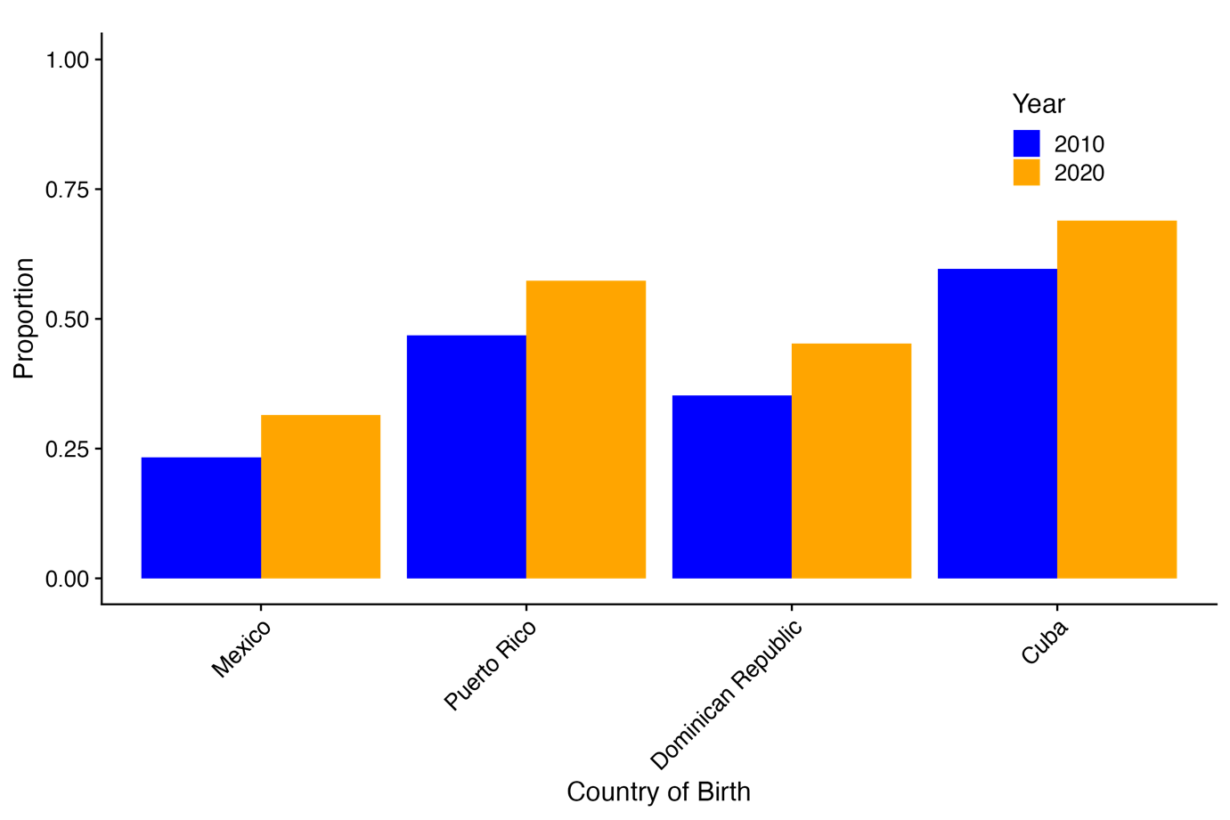

## Discussion

This study compares sociodemographic characteristics of older adult Caribbean Hispanic and Mexican-born populations both in their countries of origin and as immigrants in the United States. Aggregate statistics show that in the mid-20th century, around the time of birth of today’s older adults, economic and health conditions in Mexico were substantially worse than those in Puerto Rico and Cuba, suggesting the importance of comparative research that compares those born in each of these Hispanic Caribbean countries in more detail as distinct from Mexican-born populations.

Using national census and U.S. ACS immigrant microdata, we find that immigrant characteristics and selectivity patterns vary markedly across these countries and by cohort. In particular, Caribbean older adult immigrants have substantially higher education and citizenship levels than those from Mexico, but are less likely to be married or live with children. Furthermore, we find that at least one crucial determinant of healthy aging, education, has shown rapid changes across cohorts, indicating the importance of carefully documenting changing patterns as research looks to understand and predict changes in healthy aging patterns.

Within the Hispanic Caribbean, we find that Dominican immigrants are most similar to those from Mexico, but have even stronger positive immigrant selectivity on education. Future work to examine patterns of Dominican selectivity on other characteristics not observed here, such as health status, would be helpful for better understanding potential future trajectories of healthy aging among Dominican immigrants and how they may vary from other better studied populations such as Mexican immigrants.

This future work will be aided by the improved availability of harmonized data from these settings, including the Caribbean CADAS, Mexican MHAS, and U.S. HRS. It can build on existing comparative work using non-national samples in the Hispanic Caribbean comparing education gradients of characteristics such as cardiovascular risk factors and cognitive functioning (Dieci et al. 2021; Li et al. 2021; Llibre-Guerra 2022). It will also build on non-national samples with Hispanic Caribbean immigrants in the U.S. such as the Washington Heights and Inwood Community Aging project (Tang et al. 2001), the Boston Puerto Rico Study (Tucker et al. 2010).

An ongoing challenge though is the limited sample sizes of Hispanic Caribbean immigrants even in U.S. national datasets that target or oversample Hispanics. As a result, immigrant studies with datasets such as the HRS, the Hispanic Community Health Study/Study of Latinos (HCHS/SOL, González et al. 2019), etc., typically resort to aggregating Hispanic immigrants from Mexico and other countries (Garcia et al. 2020; Liu et al. 2025). As we have argued above, this is likely to mask important differences by national origin, and thus hampers the ability to draw informative conclusions on Hispanic healthy aging in the U.S. To better advance this research, we encourage the development of larger nationally representative samples of Hispanic Caribbean immigrant groups in the U.S.

The complexity of migration from Latin America to the United States is underscored by the region’s evolving migration landscape, which has seen a dramatic increase in intra-regional movement and return migration since 2010, challenging the narrative of unidirectional flows to North America, while still maintaining significant outward migration patterns (Tanco 2023). Additionally, our paper considers migrant populations and host countries pre-2020, and thus does not capture further changes since the COVID-19 pandemic (Hanson, Orrenius, and Zavodny 2023), nor those in response to changing immigration politics in the U.S. and elsewhere in more recent years.

Funding

This work was supported by the National Institutes of Health [R01AG064778].

Acknowledgments

The authors wish to acknowledge the statistical offices that provided the underlying data making this research possible: United States Census Bureau; Office of National Statistics, Cuba; National Statistics Office, Dominican Republic; National Institute of Statistics, Geography, and Informatics, Mexico.

# References

Aldridge, Robert W., Laura B. Nellums, Sean Bartlett, Anna Louise Barr, Parth Patel, Rachel Burns, Sally Hargreaves, et al. 2018. “Global Patterns of Mortality in International Migrants: A Systematic Review and Meta-Analysis.” *Lancet (London, England)* 392 (10164): 2553–66. <https://doi.org/10.1016/S0140-6736(18)32781-8>.

Angel, Jacqueline L., William Vega, and Mariana López-Ortega. 2017. “Aging in Mexico: Population Trends and Emerging Issues.” *The Gerontologist* 57 (2): 153–62. <https://doi.org/10.1093/geront/gnw136>.

Bahar, Dany. 2024. “The Often Overlooked ‘Pull’ Factor: Border Crossings and Labor Market Tightness in the US,” June. <https://www.cgdev.org/publication/often-overlooked-pull-factor-border-crossings-and-labor-market-tightness-us>.

Batalova, Jeanne Batalova Erin Babich and Jeanne. 2021. “Central American Immigrants in the United States.” *Migrationpolicy.org*. <https://www.migrationpolicy.org/article/central-american-immigrants-united-states-2019>.

Capielo Rosario, Cristalís, Tristan Mattwig, Kyana D. Hamilton, and Brenton Wejrowski. 2023. “Conceptualizing Puerto Rican Migration to the United States.” *Current Opinion in Psychology* 51 (June): 101584. <https://doi.org/10.1016/j.copsyc.2023.101584>.

Causa, O., and J. Pichelmann. 2020. “Should I Stay or Should I Go? Housing and Residential Mobility Across OECD Countries.” *OECD* 1626 (October). https://doi.org/<https://doi.org/10.1787/d91329c2-en>.

Cervantes, Cecilia Menjívar and Andrea Gómez. 2018. “El Salvador: Civil War, Natural Disasters, and Gang Violence Drive Migration.” *Migrationpolicy.org*. <https://www.migrationpolicy.org/article/el-salvador-civil-war-natural-disasters-and-gang-violence-drive-migration>.

Clemens, Michael A., Claudio E. Montenegro, and Lant Pritchett. 2009. “The Place Premium: Wage Differences for Identical Workers Across the U.S. Border.” {SSRN} {Scholarly} {Paper}. Rochester, NY. <https://doi.org/10.2139/ssrn.1211427>.

Dieci, M., Llibre-Rodriguez, J. J., Acosta, D., & Dow, W. H. Cuba’s cardiovascular risk factors: International comparison of levels and education gradients. Plos One, 16(3), e0247831, 2021.

Duany, Jorge. 2010. “To Send or Not to Send: Migrant Remittances in Puerto Rico, the Dominican Republic, and Mexico.” *The ANNALS of the American Academy of Political and Social Science* 630 (1): 205–23. <https://doi.org/10.1177/0002716210368111>.

———. 2017. “Cuban Migration: A Postrevolution Exodus Ebbs and Flows.” *Migrationpolicy.org*. <https://www.migrationpolicy.org/article/cuban-migration-postrevolution-exodus-ebbs-and-flows>.

Feliciano, C. 2020. “Immigrant selectivity effects on health, labor market, and educational outcomes.” *Annual Review of Sociology*, 46, 315–334.

FitzGerald, David Scott, and Rawan Arar. 2018. “The Sociology of Refugee Migration.” *Annual Review of Sociology* 44 (Volume 44, 2018): 387–406. <https://doi.org/10.1146/annurev-soc-073117-041204>.

Garcia MA, Ortiz K, Arévalo SP, et al. Age of Migration and Cognitive Function Among Older Latinos in the United States. *Journal of Alzheimer’s Disease*. 2020;76(4):1493-1511. doi:10.3233/JAD-191296

“Global Health Observatory.” 2021. *WHO*. <https://apps.who.int/gho/data/node.main.688>.

González, H. M., Tarraf, W., Fornage, M., González, K. A., Chai, A., Youngblood, M., de los Angeles Abreu, M., Zeng, D., Thomas, S., & Talavera, G. A. (2019). A research framework for cognitive aging and Alzheimer's disease among diverse US Latinos: Design and implementation of the Hispanic Community Health Study/Study of Latinos-Investigation of Neurocognitive Aging (SOL-INCA). *Alzheimer's & Dementia*, 15(12), 1624-1632. https://doi.org/10.1016/j.jalz.2019.08.192

González, Juan. 2024. “The Current Migrant Crisis: How U.S. Policy Toward Latin America Has Fueled Historic Numbers of Asylum Seekers - New Labor Forum.” <https://newlaborforum.cuny.edu/2024/05/01/the-current-migrant-crisis-how-u-s-policy-toward-latin-america-has-fueled-historic-numbers-of-asylum-seekers/>.

Hanson, Gordon, Pia Orrenius, and Madeline Zavodny. 2023. “US Immigration from Latin America in Historical Perspective.” *Journal of Economic Perspectives* 37 (1): 199–222. <https://doi.org/10.1257/jep.37.1.199>.

Henao, Carolina, Jenny Paola Lis-Gutiérrez, and Manuel Ignacio Balaguera. 2023. “Subjective Quality of Life in Latin American.” *Salud, Ciencia y Tecnología - Serie de Conferencias* 2 (September): 384–84. <https://doi.org/10.56294/sctconf2023384>.

Jonas, Susanne. 2018. *Of Centaurs And Doves: Guatemala’s Peace Process*. New York: Routledge. <https://doi.org/10.4324/9780429498596>.

Kritz, Mary M., Lin Lean Lim, and Hania Zlotnik. 1992. *International Migration Systems : A Global Approach*. Seminar on International Migration Systems. Oxford: Clarendon Press.

Larotta Silva, Sonia Patricia. 2019. “Determinantes Para La Migración Internacional de Colombianos Entre 1990-2015 a Partir de Un Modelo Gravitacional.” *Territorios*, no. 41 (December): 69–100. <https://doi.org/10.12804/revistas.urosario.edu.co/territorios/a.7414>.

Lewis, JM. 2014. “Testing alternative relationship and marital status questions on the 2013 American Community Survey—questionnaire design test.” Washington, DC: US Census Bureau.

Li, J., Llibre‐Guerra, J. J., Harrati, A., Weiss, J., Jiménez‐Velázquez, I. Z., Acosta, D., Llibre-Rodriguez, J., Liu, M. M. & Dow, W. H. Associations between education and dementia in the Caribbean and the United States: An international comparison. Alzheimer’s & Dementia: Translational Research & Clinical Interventions, 7(1), e12204, 2021.

Liu, Mao-Mei, Ariana M Stickel, Wassim Tarraf, Lehan Li, Krista M Perreira, Fernando Riosmena, Melissa Lamar, Fernando D Testai, Linda C Gallo, Tanya P Garcia, Jorge J Llibre-Guerra, Carmen R Isasi, Richard B Lipton, Martha Daviglus, William H Dow, Hector M González. 2025. “Influence of birthplace and age at migration on cognitive aging among Hispanic/Latino populations in the U.S.: Study of Latinos-Investigation of Neurocognitive Aging (SOL-INCA).” *The Gerontologist*. https://doi.org/10.1093/geront/gnaf009

Llibre-Guerra, Jorge J, Jing Li, Amal Harrati, Ivonne Jiménez-Velazquez, Daisy M Acosta, Juan J Llibre-Rodriguez, Mao-Mei Liu, and William H Dow. 2021. “The Caribbean-American Dementia and Aging Study (CADAS): A Multinational Initiative to Address Dementia in Caribbean Populations.” *Alzheimer’s & Dementia* 17 (S7): e053789. <https://doi.org/10.1002/alz.053789>.

Llibre-Guerra, Jorge, J. Li, Y. Qian, J. Llibre Rodriguez, I. Jiménez Velázquez, D. Acosta, A. Salas, Juan Carlos Llibre-Guerra, A. Valvuerdi, A. Harrati, J. Weiss, M. Liu, W. Dow. “Apolipoprotein E (APOE) genotype, dementia, and memory performance among Caribbean Hispanic versus U.S. populations.” *Alzheimer's & Dementia* 1-9 https://doi.org/10.1002/alz.12699, 2022.

Massey, Douglas S., Joaquín Arango, Graeme Hugo, Ali Kouaouci, Adela Pellegrino, and J. Edward Taylor. 1994. “An Evaluation of International Migration Theory: The North American Case.” *Population and Development Review* 20 (4): 699–751. <https://doi.org/10.2307/2137660>.

McAuliffe, Marie, Celine Bauloz, and Adrian Kitimbo. 2024. “Who Migrates Internationally and Where Do They Go? International.” International Organization for Migration. <https://worldmigrationreport.iom.int/what-we-do/world-migration-report-2024-chapter-4/who-migrates-internationally-and-where-do-they-go-international-migration-globally-between-1995-2020>.

Nevado-Peña, Domingo, Víctor-Raúl López-Ruiz, and José-Luis Alfaro-Navarro. 2019. “Improving Quality of Life Perception with ICT Use and Technological Capacity in Europe.” *Technological Forecasting and Social Change* 148 (November): 119734. <https://doi.org/10.1016/j.techfore.2019.119734>.

Noe-Bustamante, Mohamad Moslimani and Luis, Jeffrey S. Passel. 2023. “Key Facts about U.S. Latinos for National Hispanic Heritage Month.” *Pew Research Center*. <https://www.pewresearch.org/short-reads/2023/09/22/key-facts-about-us-latinos-for-national-hispanic-heritage-month/>.

Passel, Mohamad Moslimani and Jeffrey S. 2024. “What the Data Says about Immigrants in the U.S.” *Pew Research Center*. <https://www.pewresearch.org/short-reads/2024/09/27/key-findings-about-us-immigrants/>.

Pine, Adrienne. 2008. *Working Hard, Drinking Hard: On Violence and Survival in Honduras*. 1st ed. University of California Press. <https://www.jstor.org/stable/10.1525/j.ctt1pppbx>.

Steven Ruggles, Lara Cleveland, Rodrigo Lovaton, Sula Sarkar, Matthew Sobek, Derek Burk, Dan Ehrlich, Quinn Heimann, Jane Lee. Integrated Public Use Microdata Series, International: Version 7.5 [dataset]. Minneapolis, MN: IPUMS, 2024. https://doi.org/10.1 [dataset]. Minneapolis, MN: IPUMS, 2024. https://doi.org/10.18128/D020.V7.5

Steven Ruggles, Sarah Flood, Matthew Sobek, Daniel Backman, Annie Chen, Grace Cooper, Stephanie Richards, Renae Rodgers, and Megan Schouweiler. IPUMS USA: Version 15.0 [dataset]. Minneapolis, MN: IPUMS, 2024. https://doi.org/10.18128/D010.V15.0

Silva, Adriana C., and Douglas S. Massey. 2014. “Violence, Networks, and International Migration from Colombia - Silva - 2015 - International Migration - Wiley Online Library” 53 (5): 162–78. https://doi.org/<https://doi.org/10.1111/imig.12169>.

Sonnega A, Faul JD, Ofstedal MB, Langa KM, Phillips JW, Weir DR. Cohort Profile: the Health and Retirement Study (HRS). Int J Epidemiol. 2014 Apr;43(2):576-85. doi: 10.1093/ije/dyu067. Epub 2014 Mar 25. PMID: 24671021; PMCID: PMC3997380.

Tanco, Ariel G. Ruiz Soto, Valerie Lacarte. 2023. “In a Dramatic Shift, the Americas Have Become a Leading Migration Destination.” *Migrationpolicy.org*. <https://www.migrationpolicy.org/article/latin-america-caribbean-immigration-shift>.

Tang MX, Cross P, Andrews H, Jacobs DM, Small S, Bell K, Merchant C, Lantigua R, Costa R, Stern Y, Mayeux R. Incidence of AD in African-Americans, Caribbean Hispanics, and Caucasians in northern Manhattan. Neurology. 2001 Jan 9;56(1):49-56. doi: 10.1212/wnl.56.1.49. PMID: 11148235.

Tucker KL, Mattei J, Noel SE, Collado BM, Mendez J, Nelson J, Griffith J, Ordovas JM, Falcon LM. The Boston Puerto Rican Health Study, a longitudinal cohort study on health disparities in Puerto Rican adults: challenges and opportunities. BMC Public Health. 2010 Mar 1;10:107. doi: 10.1186/1471-2458-10-107. PMID: 20193082; PMCID: PMC2848197.

United Nations Inter-agency Group for Child Mortality Estimation (2023). <https://childmortality.org/>.

U.S. Customs and Border Protection. 2024. “Nationwide Encounters U.S. Customs and Border Protection.” <https://www.cbp.gov/newsroom/stats/nationwide-encounters>. Accessed DATE.

Valentine, Jessa Lewis, Brad Barham, Seth Gitter, and Jenna Nobles. 2017. “Migration and the Pursuit of Education in Southern Mexico.” *Comparative Education Review* 61 (1): 141–75. <https://doi.org/10.1086/689615>.

Winkler, Hernan. 2016. “How Does the Internet Affect Migration Decisions?: Applied Economics Letters: Vol 24 , No 16 - Get Access.” *Applied Economics Letters* 24 (16): 1194–98. https://doi.org/<https://doi.org/10.1080/13504851.2016.1265069>.

Wong R, Michaels-Obregon A, Palloni A. Cohort Profile: The Mexican Health and Aging Study (MHAS). Int J Epidemiol. 2017 Apr 1;46(2):e2. doi: 10.1093/ije/dyu263. PMID: 25626437; PMCID: PMC5837398.

“World Development DataBank.” 2025. <https://databank.worldbank.org/indicator/NY.GDP.PCAP.CD/1ff4a498/Popular-Indicators>.

“World Population Prospects.” 2024. <https://population.un.org/wpp/>.

## Table Titles

Table 1: Hispanic Immigrants Ages 60+ Living in US (2016-2020 ACS), and Birth Country Demographic Indicators

Table 2: Sociodemographic Comparison of Hispanics Ages 60+ in the U.S. by Birth Country (2016-20 ACS)

Table 3: Sociodemographic Comparison of Hispanics Ages 60+ by Birth Country: Non-Migrants versus US Immigrants (2010)

## Supplemental Materials

### Variable Definitions

**Education Levels:** We standardize education groups across countries based on years of schooling (categories add up to less than 100% in samples that include individuals with missingness in the years of schooling variable):

* “**Less Than Primary**” includes individuals with education levels such as “grade 1” through “grade 5,” “kindergarten,” “no schooling completed,” or “nursery school, preschool.”
* “**Primary Completed**” includes those who completed grades 6 through 11, representing completion of primary education but not secondary school.
* “**Secondary Completed**” includes individuals with 12 years of schooling, a “regular high school diploma,” or partial college experience without a bachelor’s degree.
* “**University Completed**” includes individuals with a bachelor’s degree or higher (master’s degree, doctoral degree, or professional degree beyond a bachelor’s).

**Household composition:**

* Household size is a measure of the respondent’s “own family” living in the household, including themselves.
* “Lives Alone” is defined as a household size of 1.
* “Lives with Child” refers to respondents who report one of their household members as one of their children.

**Married:** The US Census status classification identifies four major categories: never married, married, widowed, and divorced. These terms refer to the marital status at the time of the enumeration. The “married” category is defined as those who responded “married, spouse present,” implying that the spouse lives in the household.

In the International samples, we code as “married” those who responded: “married, formally”; “married, civil”; “married or consensual union; “married, religious”; “married, civil and religious”; or “consensual union.”

**Citizen:** U.S. citizen by naturalization.

**English Speaker:** We define an “English speaker” as anyone who says they speak English, including those who say “yes, but not well.”

### Supplemental Table Titles

Supplemental Table 1: Sociodemographic Comparison of Hispanics Ages 60+ in the U.S. by Birth Country (2016-20 ACS): Females

Supplemental Table 2: Sociodemographic Comparison of Hispanics Ages 60+ in the U.S. by Birth Country (2016-20 ACS): Males

Supplemental Table 3: Sociodemographic Comparison of Hispanics in the U.S. by Birth Country (2008-10 ACS)

Supplemental Table 4: Sociodemographic Comparison of Hispanics in the U.S. by Birth Country (2016-20 ACS): Migrated After Age 24

Supplemental Table 5: Age-Standardized Sociodemographic Comparison of Hispanics Ages 60+ by Birth Country (~2010)

Supplemental Table 6: Summary Statistics by Country and Sex, Comparing 2010 versus 2020

Supplemental Table 7: Changing Educational Attainment of the 1930-1950 Birth Cohort due to Selection: 2010 versus 2020

### Supplemental Plots

Supplemental Figure 1. Infant Mortality Rate Trends in Countries of Interest Over Time (1950-2019)

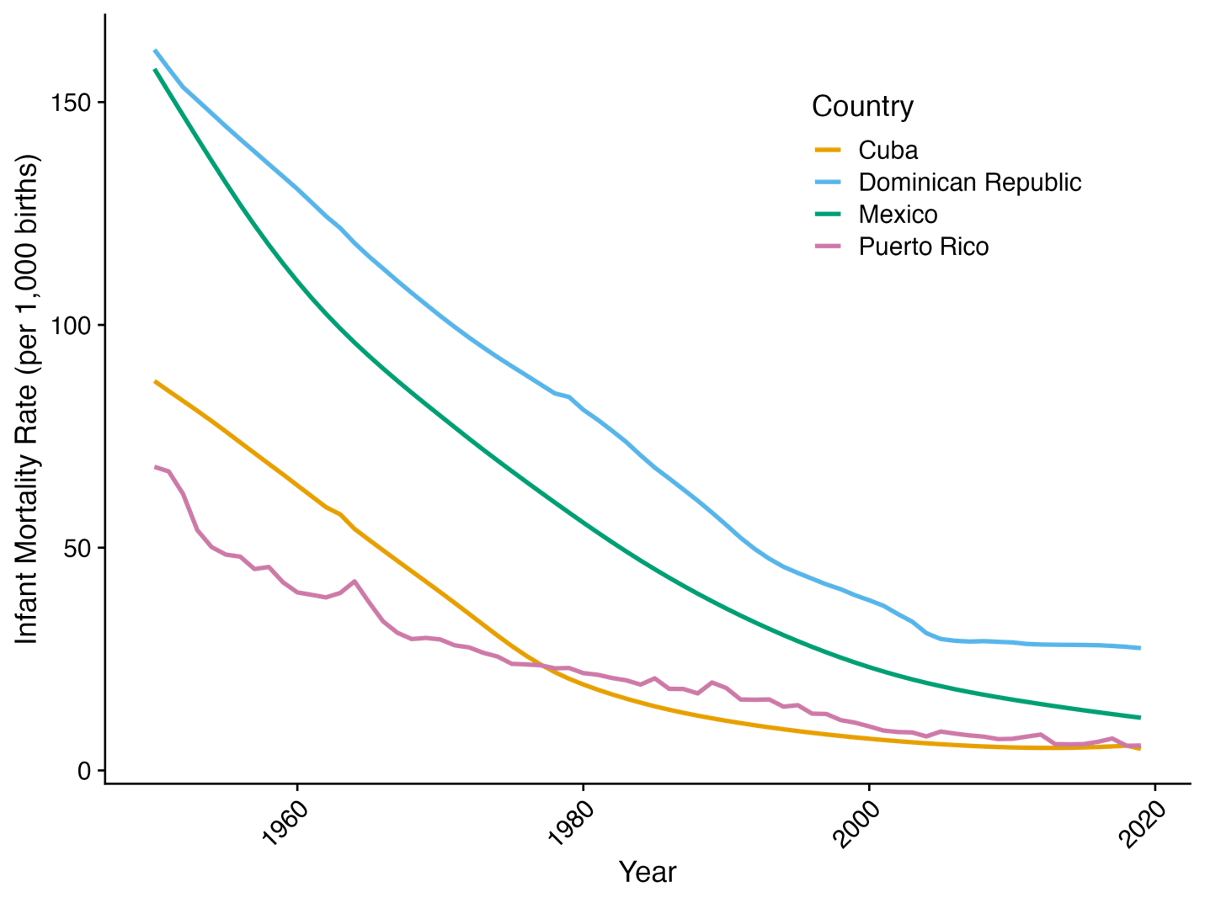

Supplemental Figure 2. Estimated Percent with At Least a Primary Education by Country of Birth (2010 ACS)

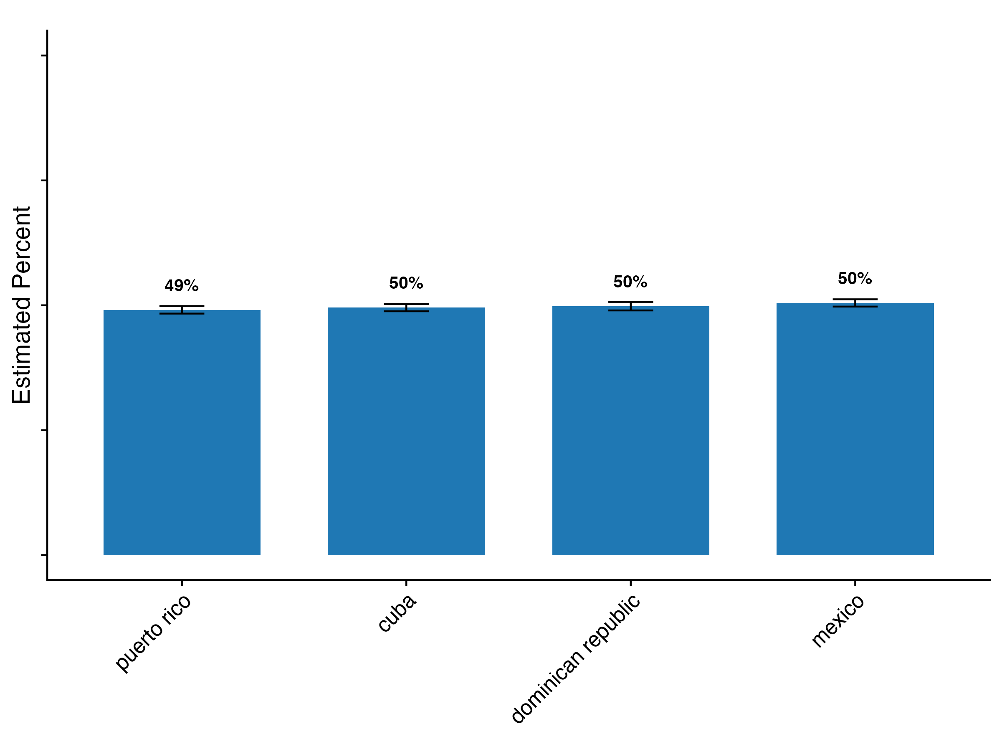

Supplemental Figure 3. Estimated Percent with At Least a Secondary Education by Country of Birth (2010 ACS)

Supplemental Figure 4. Estimated Percent Living Alone by Country of Birth (2010 ACS)

